5 Relating Mass, Speed, and Force | 3 Collisions and Momentum | Spring 2024
What students will figure out
- The momentum of an object is the product of its mass and its velocity.
- The total momentum of two objects in a collision is conserved when there are no small external forces on two objects during a collision; momentum conservation provides a close approximation of the outcomes, when the external forces on the objects (e.g. friction) are much smaller in magnitude than the average collision force.
Personal Glossaries
Delta(Δ)
Elastic Collision
Inelastic Collision
Momentum
Materials
- Elastic and Inelastic Collisions Sim
- Computers
- Mathematical Relationships (in Science Notebooks)
- Momentum relationships poster

1 Navigation | Considering Velocity and Mass in a Collision
We see that velocity is conserved when masses are the same
When masses are different, a different quantity is conserved

2 Simulation | Elastic and Inelastic Collisions
Introduce students to the simulation

Type of Collision | M_{A} | V_{0A} | V_{fA} | M_{B} | V_{0B} | V_{fB}
Elastic
Inelastic
- Does the mathematical relationship we found for collisions E-F hold true for non, one, or both of these collisions?
- Show your thinking with mathematics
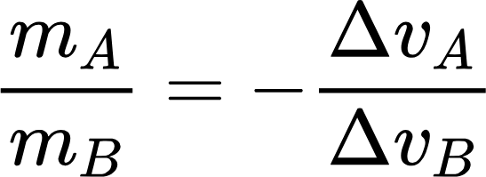

3 Mathematics | Manipulate Equations to Conserve Physical Quantities
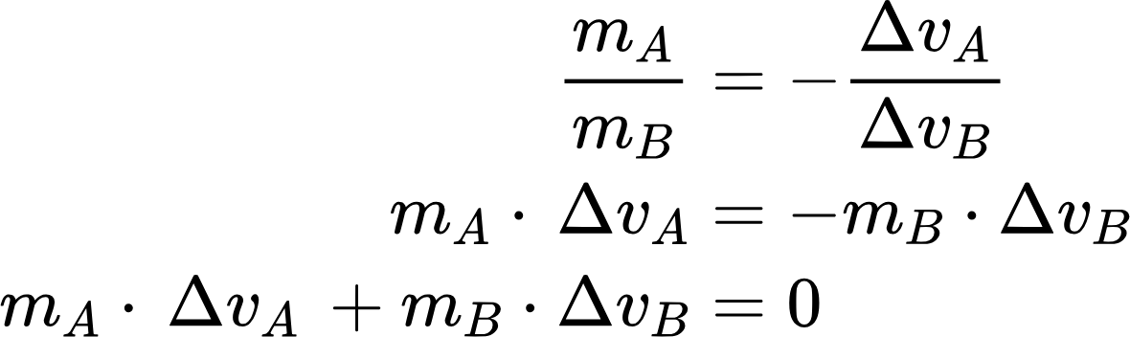

4 Mathematics | Geometric Model of Conservations

5 Discussion | Momentum
Introduce momentum as the actual quantity being conserved

6 Mathematics | Momentum Equation

7 Mathematics | Alternate Form of Momentum Equation

8 Prediction | Solving for an Unknown

9 Personal Glossaries
Delta(Δ)
Elastic Collision
Inelastic Collision
Momentum

10 Handout | Momentum Cases
Students review sample problems and attempt calculations
Teacher redirects questions/ideas to the whole-group

11 Self-Assessment | Solving with Momentum
Students use posted answer key to check their work
Teacher reviews calculation and discusses nuances

12 Discussion | Connecting Force and Momentum
Through the cart trials we see that the conserved quantity is momentum

